Fertilization/ Pregnancy/ Childbirth

Fertilization
- Possible result of copulation
- Sperm travels from the uterus, eventually reaches the fallopian tubes and meets the ovum in the upper thirds of the tube.
- Only few __________ reach the ovum.
- Acrosome releases enzymes to dissolve the ovum membrane and allows one sperm to penetrate and fertilize the egg.
- This causes a barrier to instantly form, preventing the penetration of other sperm.
- Genetic material of egg and sperm unite.
- Egg has ____ chromosomes (__________) + sperm has ___ chromosomes = zygote with ____ chromosomes (___________)
- ________________________________________________________________.

Implantation
- Process of the fertilized egg (zygote) embedding in the wall of the uterus (menstruation does not occur)
- During implantation, an outer layer of cells surrounding the zygote produces HCG (human chorionic gonadotropic hormone) that prevents degeneration of corpus luteum and causes it to secrete even larger quantities of progesterone.

Embryo –

Fetus –

Developmental Process
- While development is occurring, these processes take place:
- Cleavage –

- Growth –
- Morphogenesis –

- Differentiation –

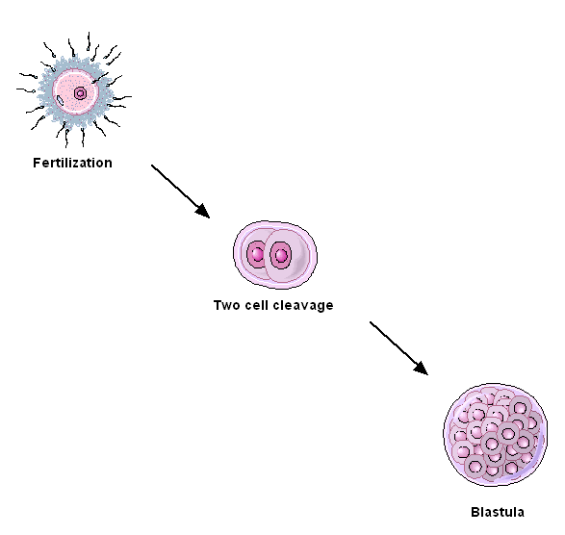

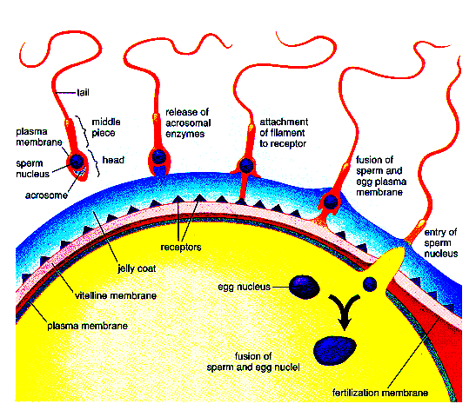
Embryonic Development
First Week
- By the time the embryo has reached the uterus on the third day, it is a ______________

- About the fifth day, the morula has transformed into the ______________________
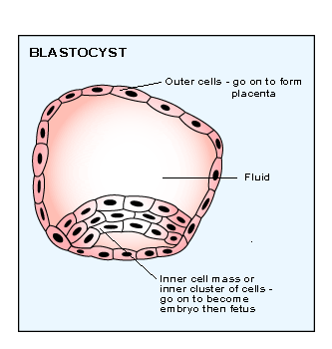
NOTE: __________________________________________________________________________________
__________________________________________________________________________________
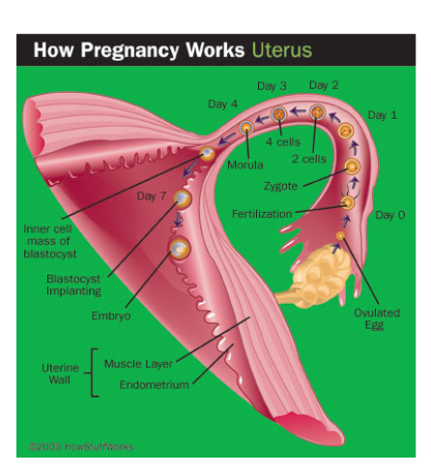
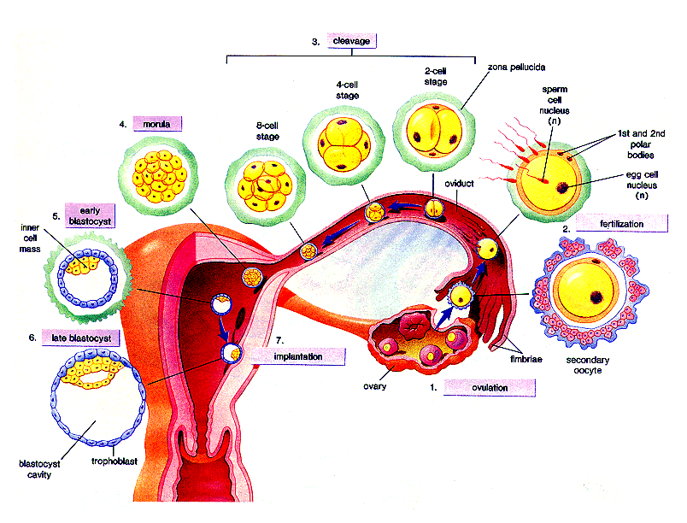
Second Week
- Embryo implants itself in the wall of the uterus
- ________________secretes enzymes to digest away some of the tissue and blood vessels of the uterine wall
- Embryo is about the size of a period at the end of a sentence (.)
- ___________________ begins to secrete ________
  - Serves to maintain the _____________________ past the time it would normally disintegrate
  - ________________________ is maintained and menstruation does not occur
Third Week
- The germ layers (ectoderm, endoderm and mesoderm) are laid down during the third week of development
- Development of each of the organs can be related to certain of the germ layers
Ectoderm

Endoderm

Mesoderm

- Two cavities are formed:
- Amniotic cavity –

- Yolk sac –

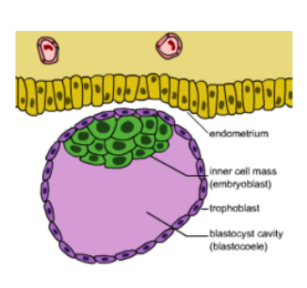
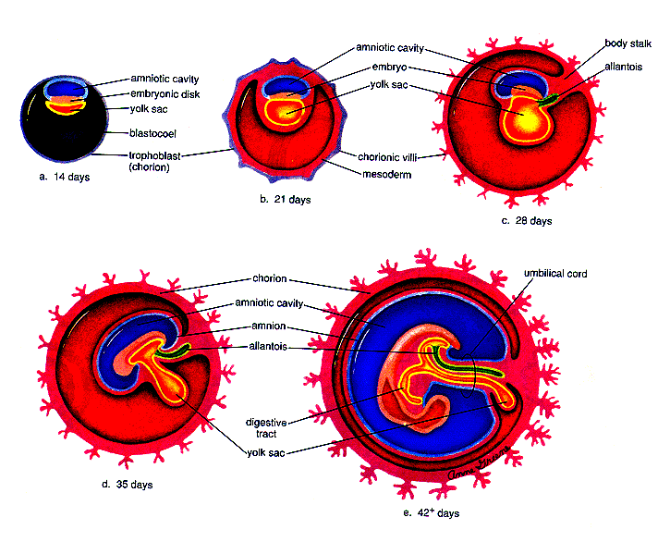
- During the fourth week major organs like the central nervous system and the heart make their appearance.

- During the fifth week, human features like the head, arms, and legs begin to make their appearance.

- During the third and fourth months, it is obvious that the skeleton is changing from cartilage to bone. The sex of the individual is now distinguishable.

- From the fifth to the ninth month, the fetus continues to grow and gain weight. Babies born after six to seven months may survive but are subject to various illnesses that may have lasting effects or cause an early death.
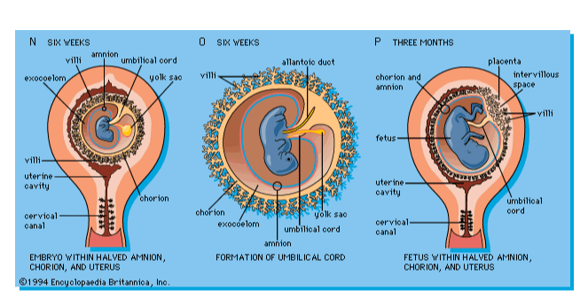
Uterine Structures for Growth:
See Diagram
Amnion –

Amnionic Fluid-
- Fluid within the amnion surrounding the fetus
- It serves as a shock absorber for the fetus
- Ruptures before birth “water breaks”

Amniocentesis (technology) – procedure to remove amniotic fluid
- Cells are cultured
- Used to detect Down Syndrome

Placenta
- Begins forming once the embryo is fully implanted
- Blood filled structure through which nutrients and wastes are exchanged between embryo and mother
- Accomplished by third month of pregnancy
- Shape of a flat cake
- Formed by the _____________(outer layer of embryo) and endometrium of mother
- Finger like projection of the chorion called ____________________ grow into the endometrium. They contain fetal blood vessels that are brought into close proximity with moms blood vessels.
- THERE IS NO EXCHANGE (MIXING) OF MATERIAL AND FETAL BLOOD.
- Oxygen and nutrients diffuse into capillaries of the villi from mom
- From the capillaries nutrients circulate into the __________________
- Wastes leave the fetus through umbilical arteries > capillaries > mother
- Placenta = bridge + barrier
(small molecules (large cells + proteins in
O2, glucose diffuse) moms blood do not diffuse)
- When placenta is fully formed, it begins to produce progesterone and estrogen
  - _____________________________________________________________
  - _____________________________________________________________
Yolk sac
- Temporary function in humans
- Major role in animals hatching from eggs (major nutrient source)
- In humans, produces blood production tissues are available

Umbilical cord
- Connects developing fetus to placenta
- Consists of one vein and two arteries

Umbilical vein – oxygen and nutrients from mother to fetus

Two umbilical arteries – wastes and carbon dioxide from fetus to mother for removal
P 422 and 423 in text

SEX DETERMINATION
- 6th week, the gonads are starting to produce hormones that will influence the development of the external genitalia
- Up until the 6th or 7th week, male fetus does not differ from female fetus
- Sex-determining region of the Y chromosome (SRY) is gene mainly responsible for determining the male phenotype
- XX XY
- Hormones direct development of male characteristics
- Testes develop inside the body cavity in same location as ovaries and gradually descend
- Female sex determination is even more complicated
- Sex is also determined by hormones in the blood stream
- Women do produce some androgens and males produce small amounts of estrogen
- Hormone balance between male and female sex hormones is most critical during fetal development
- Too much estrogen at the wrong time can transform an organism with male genes into what outwardly appears to be a female and vice versa

